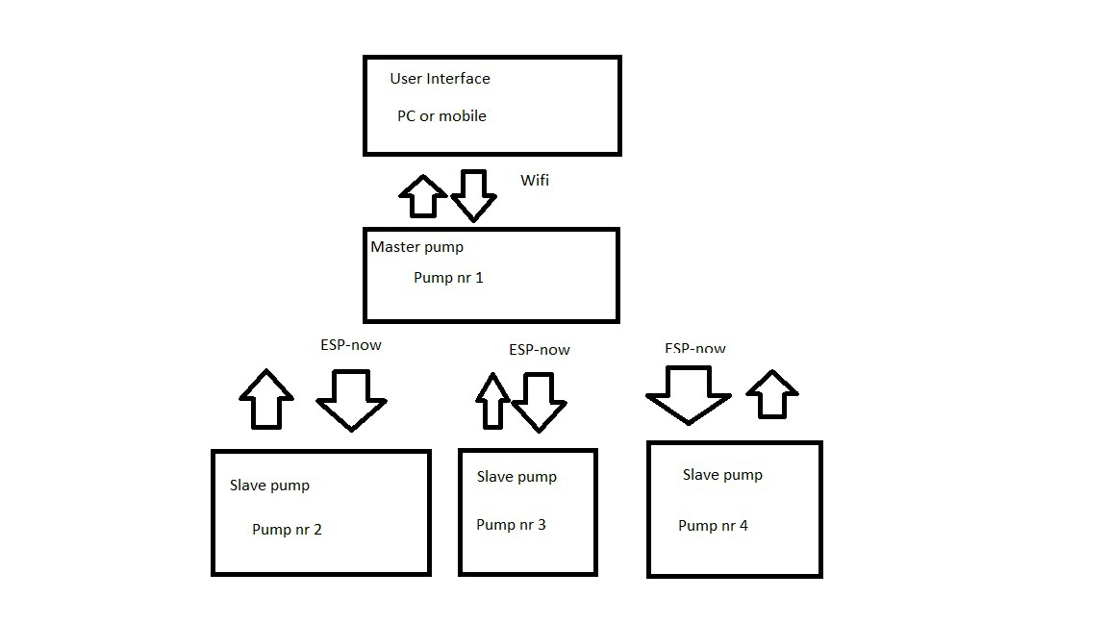

ESP2ESPCOM_v1.31

ESP2ESPRecieve_v1.31

* The user can connect to master pump.
* Master pump can be configured through the PC or mobile interface.
* In the Interface any slave pump can be added by knowing the MAC Address of the slave.
* The interface is adding the slave pump MAC address into the master’s pump slave list. When it’s successful then it’s saying: “Connection established.” It is adding the MAC address even when the slave is not connected. When slave is online then it’s automatically connecting the device.
* By getting the message “Connection established” the interface is bringing up the slave pump configuration sliders and buttons. When the slave is not connected, then right now the UI doesn’t get the feedback info through the master pump if the slave is online or received configuration.
* That info can be seen through master pump serial communication connection. It was easier to keep the ESP-NOW communication protocol and the UI communication between master pump separate and not to mix the callbacks.
* Right now, the slave pump has the master’s pump MAC address hard coded in the code. So, with different master controller the MAC address in the ESP2ESPRecieve code should be changed. It’s needed for receiving feedback info in master pump. It should work without changing as well, but then no feedback is received and then debugging is harder.
* Maximum number of slaves is right now 2, but it’s possible to add more slaves.
* Right now, the slave pump is not having an UI and cannot be controlled by itself. It can be controlled through the master pump.
* The UI get’s feedback from Master pump if the sent messages were received.

Standard or basic features:

* It’s possible to set the flowrate of the pump from 12ml/min up to 72ml/min
* It’s possible to set the time for pumping up to 120seconds.
* It’s possible to switch the pump on and off.